University of the People

CS4404 Advanced Networking and data security

Unit 1 Written Assignment 1

Anonymous Student

**Introduction**

This assignment is captured the new Laptop traffic as I am working as the associate network engineer for AXY Systems Inc. This captures my network traffic record by using Wireshark.

**Capture the traffic using Wireshark**

Step ii

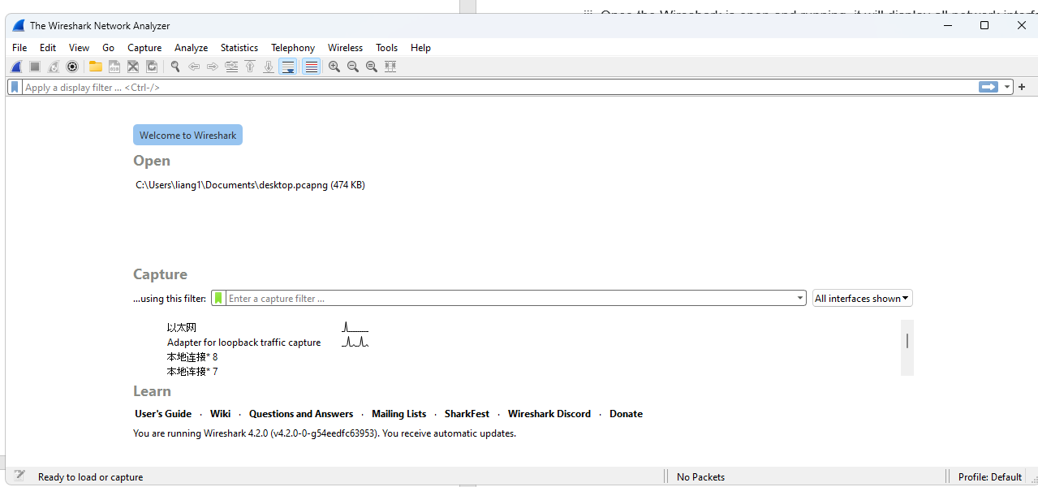relaunch Wireshark after closing all the tabs in browser

Step viii

after launch course forum the traffic was being captured in below console.

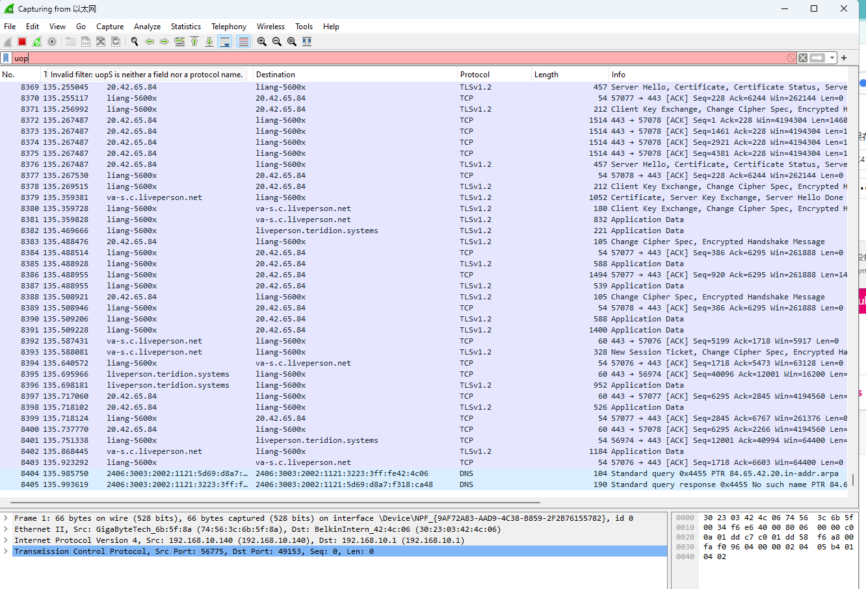

Step ix

After 30 sconds, the traffic packets is being captured in below files(*Wireshark User’s Guide*, n.d.).

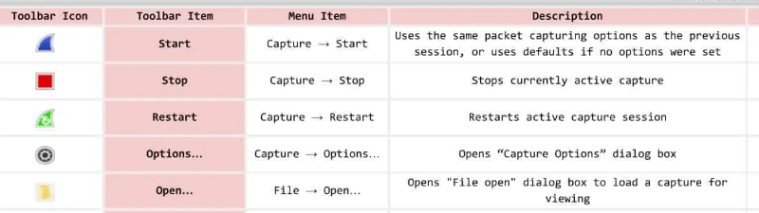

(*Wireshark Cheat Sheet - Commands, Captures, Filters, Shortcuts & FAQs*, n.d.)

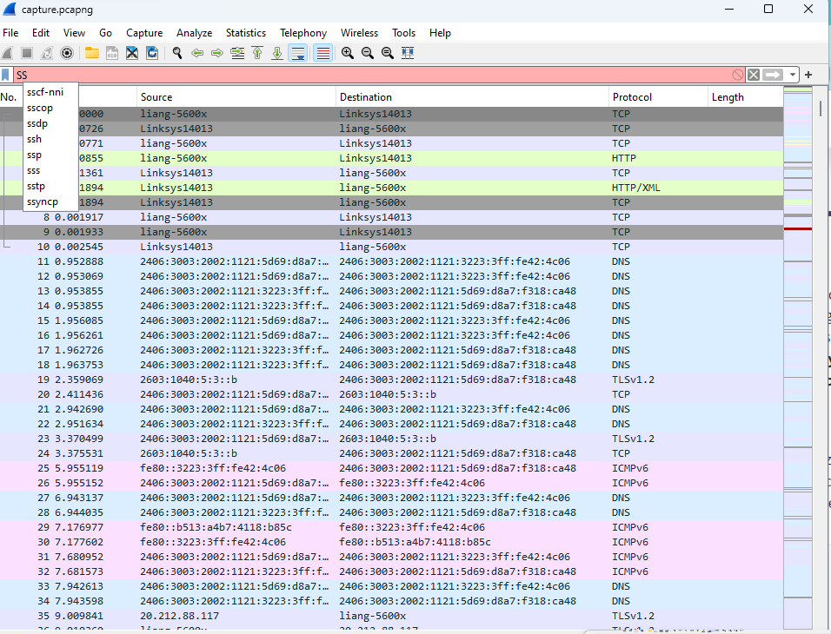

**Conclusion**

Overall, through this practice, I have successfully installed the Wireshark that is the network pakcge inspection tool(*What Is Wireshark and How to Use It | Cybersecurity | CompTIA*, n.d.). By utilizing such a tool, I am able to capture and statrt to analyse the packges incoming and outgoing for my PC.

**Reference**

*What Is Wireshark and How to Use It | Cybersecurity | CompTIA*. (n.d.). Retrieved November 19, 2023, from https://www.comptia.org/content/articles/what-is-wireshark-and-how-to-use-it

*Wireshark Cheat Sheet - Commands, Captures, Filters, Shortcuts & FAQs*. (n.d.). Retrieved November 19, 2023, from https://www.comparitech.com/net-admin/wireshark-cheat-sheet/

*Wireshark User’s Guide*. (n.d.). Retrieved November 19, 2023, from https://www.wireshark.org/docs/wsug_html_chunked/index.html